**Buddhist Holidays**

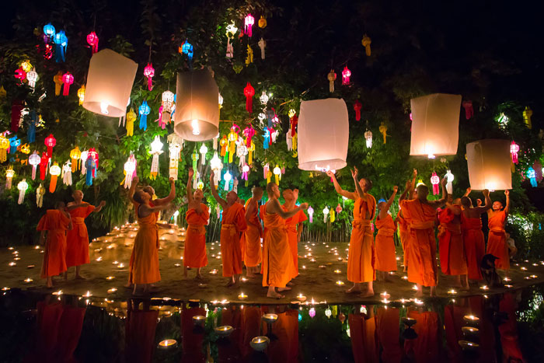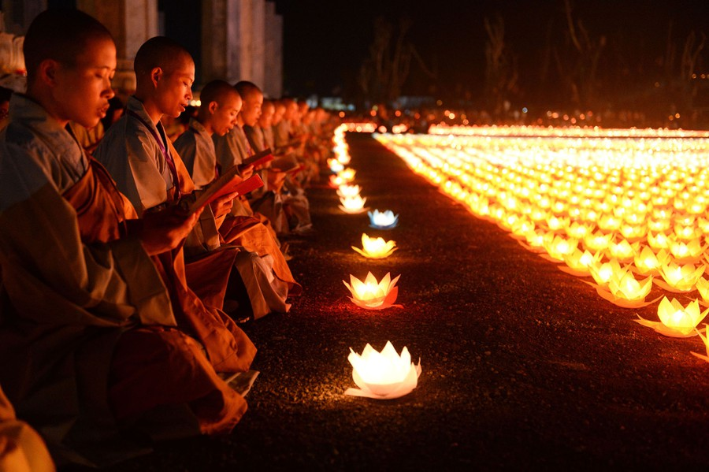For three days after the first full moon of April, Buddhists celebrate New Year’s Day in certain countries. In other countries, the New Year is celebrated around the full moon in January. The time it is celebrated depends on the country and people. For example, people in Tibet celebrate at the full moon of February, while people in China, Vietnam and Korea celebrate at the end of January or the beginning of February.The Tibetan New Year is called 'Losar'

It lasts for three days. On the first day, Tibetans celebrate with their families. On the second and third days, they celebrate with friends. The monks decorate the monasteries, and then the Tibetans go to the monasteries to offer things to purify and cleanse themselves. There are special religious ceremonies that include rituals to get rid of evil spirits. People clean the buildings in their towns, get new clothing and prepare feasts.